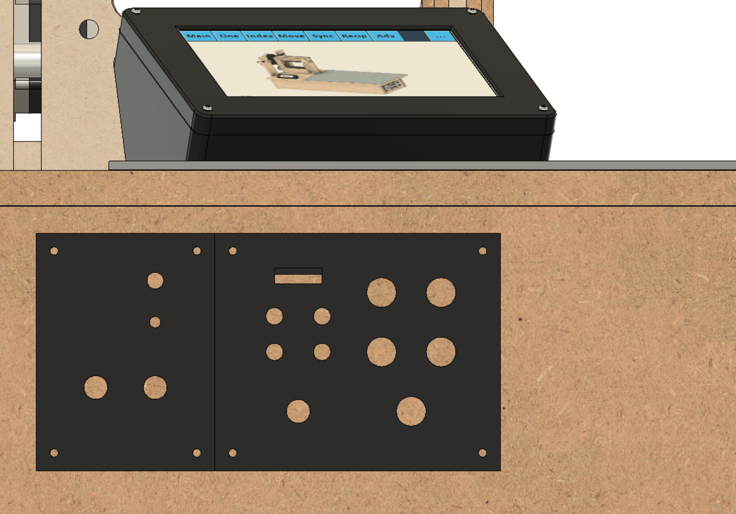

Memory Card

Display

Spindle

M3 / B

M4

X

Z

E-stop

Other

Max

Min

Limit Switches

Overhead Drive On

Overhead Drive Reset

Overhead Drive Power

Main Power